South West Adelaide’s Residential Heritage
‘When you look at a house, can you guess how old it is?
Houses can tell the whole history of South Australia if you know how to read the signs.’

In 1837, Surveyor-General, Colonel William Light, established key physical characteristics of Adelaide when he selected the site, laying out a city in a spacious and regular form, in two sections north and south of the River Torrens, each subdivided into town acres interspersed with public squares and thoroughfares, and the whole surrounded by Park Lands which acted like city walls to prevent continuous urban development. Within the city boundaries there quickly developed regions and communities each with distinctive characteristics, based largely on the chief activities in these areas.

The South Western area, removed from the intense commercial and cultural activity which began on North Terrace, Hindley and Rundle Streets, attracted mostly people from the ‘labouring classes’ who were able to afford only the very small allotments offered for sale by land owners who subdivided their original Town Acres. Many could not even afford these tiny lots and were forced to pay more than 50% of their income in rent, for what eventually became very squalid hovels due to their poor construction. There were no laws in place to regulate subdivisions, so some landowners were able to take advantage of high land prices to divide their properties into lots of only 3-5 metres in width or build row houses to rent for very high prices.

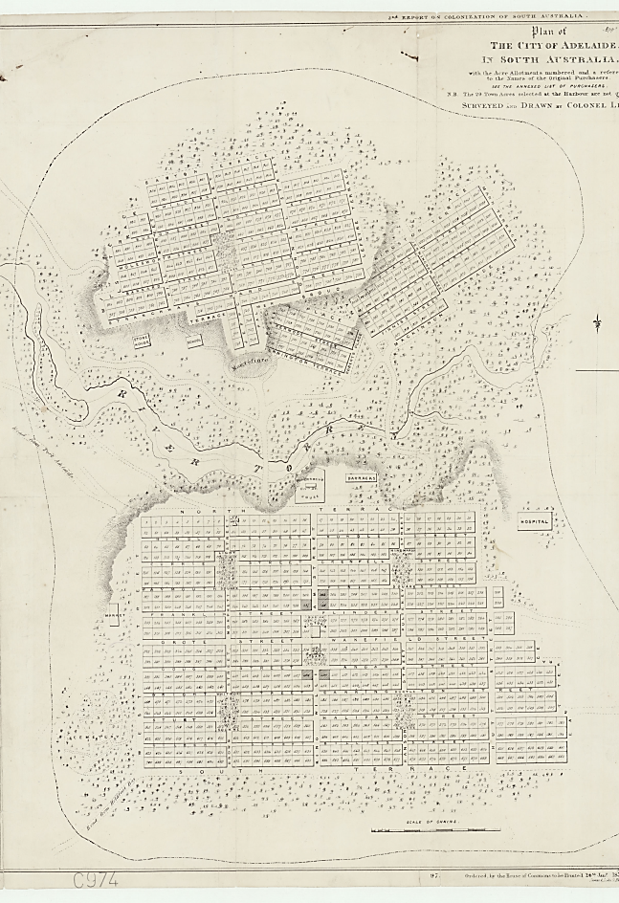 | 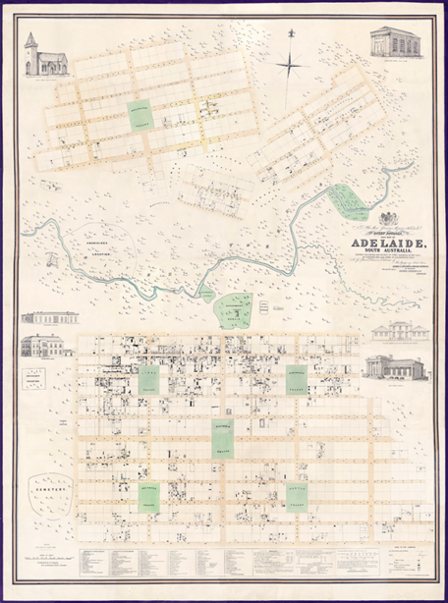
Colonel Light’s City Plan 1837 showing his allocation of town allotments to the north and south of the fertile plain surrounding the River Torrens.  Note the provision for wide avenues circling the city and also running west to east to take advantage of the ‘cleansing sea breezes arising in the west’. Light made provisions for a ‘belt of green parklands’ to surround the city and also 5 main squares for the ‘leisure pursuits’ of its citizens. | 1842 map by George Strickland Kingston showing Adelaide’s growth as a settlement and the concentration of the dwellings within easy reach of the River Torrens. At this point, only the main streets had been constructed and they were covered in loose gravel which made travel by horse, or horse-drawn cart, slow and cumbersome. When it rained, large pot-holes formed and the roads became even more uneven and treacherous. There was no sewerage, so rubbish and personal waste had to be carted away & was dumped in the parklands to the north west of the city. Instances of the rubbish leeching into the only water supply – the Torrens river – were widely condemned by local newspapers. Typhoid fever, cholera & dysentery were rife.

Timeline of infrastructure developments within city of Adelaide
1837 | Land allocated to people with land orders, remainder sold by auction.  Water carried by horse-drawn carts from River Torrens. Effluent carted away and dumped on open land.
1839 | Port Road opens – first road built
1856 | First telegraph & steam railway opened between Adelaide & Port Adelaide.  Waterworks & drainage commission established in response to major problems with Dysentery.
1858 | Melbourne-Adelaide telegraph line opened. Adelaide-Gawler steam train line opened.  Building Act outlaws use of timber roof shingles because of attraction to termites & high risk of fire.  The macadamizing of city streets begins (20 yr process).
1860 | First supplies of reticulated water reach Adelaide homes from the Kent Town Valve House.
1862 | First reservoir water piped from Thorndon Park Reservoir.
1863 | First gas supplied to city
1867 | First gas lit street lamps installed in Adelaide (1st city in Australia)
1878 | First horse-drawn trams begin operation in Adelaide (1st city in Australia)
1882 | First water-borne sewerage system (deep drainage network) commenced
1900 | First electricity station opened in South Australia at Grenfell Street. Electric street lights first appear.
1909 | Electric tram services begin within city, then to outer suburbs in 1920s.
1920s | Proliferation of heavy manufacturing industries

CENSUS FIGURES
*After WWI (1914-1918) the South Australian government actively encouraged the settlement of returned soldiers to the Adelaide suburbs and country regions by offering them cheap land. It also encouraged factories (especially noxious ones) to vacate the city to industrial zones in outer suburbs. These moves resulted in a steady decline in population within the city centre. The population of the city changed to those looking for ultra-cheap housing which was dominated after WWII (from 1945) with new arrivals from Europe. By the 1970s, these populations were also moving to modern housing in the burgeoning suburbs. In the 1980 and 1990s, many areas of housing in the city, considered to be sub-standard, were demolished to make way for offices, warehousing and hi-rise student accommodation. The “gentrification” of this area of the city has been slower than other areas, but the increasing number of high-rise towers is a telling sign of future development trends.
Population of City of Adelaide
1836 | 544
1838 | 6,000
1840 | 14,600
1844 | 17,300
1861 | 23,300
1871 | 27,200
1876 | 31,600
1881 | 38,500
1901 | 43,000
1925 | 38,000
1935 | 30,000
1948 | 35,000
1958 | 25,000
1971 | 16,300
1981 | 12,700
1991 | 14,800
2015 | 21,000

50% of the residents currently living in the Adelaide city centre are overseas born
Adelaide City Council believes that the city centre can sustainably support 47,000 residents by the year 2030.

3,428 | 1.5 | 1.9 | 10,719
number of families | average children per family | average people per household | number of private dwellings
CURRENT STATISTICS FOR RESIDENTS IN ADELAIDE
Curre
curr

KEY FEATURES OF THE SOUTH –WESTERN CORNER OF ADELAIDE

- Geology and Topography
The city tilts gently westwards so that storm water runs into the West Park Lands and the cemetery area which is one of the lowest areas in the city. Before deep drainage and the construction of macadamized roads, houses in this area were often flooded and movement was severely restricted due to boggy streets. Typhoid and other diseases flourished in these conditions.

- Population changes – legacy of waves of migration
The original inhabitants of the Adelaide Plains were the Kaurna aboriginal peoples. In the survey for the site of Adelaide a tiny area was officially marked out, near the current site of the Adelaide Oval, to contain the Native (Aboriginal) Location. Until the 1920s, the South and Western Parklands were camping grounds for aboriginal groups who were displaced from coastal locations by the first European settlers.

Migration to Adelaide has been in waves, usually due to world events such as wars, famines and religious persecution. These waves highlight the period of initial colonial settlement:
- 1840s British, Scottish & Irish immigration (particularly Irish women who were required for domestic service),
- 1850s mining boom and religious refugees (particularly German/Prussians – who went on to settle Klemzig, Barossa)
- 1870s Chinese and German female domestic servants,
- 1900 Middle Eastern migration,
- 1920s first Greek & Italian communities
- 1930s Germans of Jewish faith
- Late 1940s European displaced persons and war refugees (Greek, Italian, Dutch, “Balts”, Polish, Croatian, Russian)
- 1970s South East Asians and Chinese.
- 1990s Middle Europeans escaping collapse of former Yugoslavia
- 2000s African and Middle Eastern communities
Physical evidence of specific ethnic groups and their early building activity remains scattered throughout the city, including in the SW corner. Of note are the Prince Albert Hotel in Wright Street (German/Prussian community), the Mosque in Little Gilbert Street (North Indian/ Afghan community), the Lebanese Consulate on South Terrace, the Greek Orthodox Church and club rooms on Franklin Street, St. Patrick’s Church on Grote Street (Irish community) and the extensive Chinatown precinct around Gouger Street, the Italian Migrant Centre in Lowe St (Filef) which once housed an Italian child care centre and was opposite the first ‘macaroni factory’.

- Land use - worker’s cottages mixed with factories, warehousing.
Subdivision of a Town Acre averaged about twelve lots but sometimes as many as twenty-six lots were created which, apart from private housing, usually included a shop or two and perhaps a hotel. During the 1840s there was little regard paid to the health and welfare of the city or indeed the condition of the streets. Even less consideration was given to providing a clean and reliable water supply or the orderly development of the city generally. There was also no consideration for the well-being of the Park Lands. Only with the resuscitation of the city corporation were such issues addressed.

As the average family size was about seven children before 1900, when the number of lots is multiplied by each family size, the number of people living within a small space of an acre was often well over fifty people. Subdivision of Town Acres from the mid 1850s saw the south-western corner of the city become an area with narrow streets of small workers' cottages and tiny row houses, often with frontages directly onto the streets, low slung rooves, narrow casement windows. These properties often had shared lavatory and bathing facilities and quickly developed into slum areas. However, Alfred, Maxwell & little Gilbert Streets still offer some examples of these dwellings which were preserved by the Italian and Greek migrants who flooded into the area in the 1950s.

Economic activity in the city between 1850-1950:
13 foundries, 113 factories, over 300 warehouses

Manufacturing included - clothing & boot making, machine parts, soap, candlemaking & and chemical/fertilizer manufacturing, brick & tile manufacturing, furniture & whitegoods production, domestic tooling, coach & carriage building & allied industries (saddlery, rubber tyre making – both Rolls Roys & Holdens manufactured cars here in the 1920s), poultry & egg farming & processing, butchery & smallgood productions, flour milling & bakeries, tobacco production, building materials, saw-works etc.

The city also included thousands of small shops & family run businesses and up to 10 department stores. Most Banks & Government offices had headquarters in the city. Most professionals also had offices in the city. Most private and public high schools were housed in the city (at least until after WW1).

The city was also the place where most entertainment venues operated.

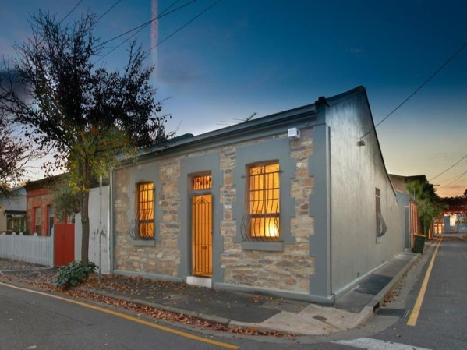

50 Alfred Street
Recently sold for $410,000

Original layout would have been 4 rooms – 2 on each side of a central corridor. House would have consisted of 2 bedrooms, a lounge (parlour) and an eat-in kitchen. The toilet/bathroom (outhouse) would have been a separate tin shed at the back of the property. There were probably a couple with 5-8 children living here.
Architectural features of the house:  Year built: 1870  Style: Symmetrical 4 roomed stone worker’s cottage  Building material: bluestone with red brick quoins. Sash windows, timber door with transom window above (leadlighted). Gabled, hipped roof with corrugated iron cladding. | Possible missig items:  - Front verandah  - Window shutters  - Rear yard from which night cartman was able to collect waste
Architectural terms:  Quoins – corners/edges of a building – usually made of red brick because easier to make square. However, bricks were very expensive because of the cost of the high heat source needed to bake them. In the early days of the colony, before coal was discovered, wood burners just didn’t get hot enough to make reliably strong bricks.  Gabled roof – roof which has a pointy end.  Hipped roof – roof which finishes at the edge of the wall  Sash windows – windows which are hung with cords at the side – to open the windows the 2 separate panes are slid up or down the cords/sashes. | In 1870, this was a substantial house for someone from the working class. Most likely, the head of the household also conducted their business from the rear yard e.g. saddlery (making leather saddles for horses, or leather collars for all types of equipment/ machines).  Reflection question:  What features of the house as it stands now are not original to the 1870 footprint?

What to look for while you are strolling:

- Cnr Grote / Gray St. – 1900’s - Victorian Bluestone workers row cottages – 3 roomed cottages with detached outdoor washing/lavatory

- Blenheim St – distribution centre, Australia Post (former home and garden of Charles Kingston, a Premier of SA and supporter of women’s suffrage)

- Cnr Blenheim/Churchill St. – more surviving worker’s row cottages from 1900s – red brick

- Cnr Gouger /Lowe st – concentration of Italian born migrants – Borgia’s operated a macaroni factory in the 1920s, butchers/smallgoods makers; Milazzo – statue maker (now prominent SA building company), Cipriani – mosaic makers, Cometti –stone mason –both sponsored by Adelaide Architects to migrate to Adelaide to work on marble sculpting & decoration of Parliament House in 1930s; – Lowe St: Filef (Italian worker’s co-operative still survives in this area)

- Cnr Lowe St/Alfred St – quaint surviving very early Bluestone cottages from 1840s – Maud & Mary Streets –surviving private laneways - tiny worker’s cottages (freehold) – small casement windows, red brick quoins, wooden shutters – evidence of established gardens in the rear – some of the oldest cottages in Adelaide!

- Wright Street – very residential feel – more substantial tradesmen’s/ worker’s cottages

- Cnr Lowe St / Wright St – Prince Albert Hotel – 1860s – owned by German/Prussian family – home of a famous German choir; first female publican in SA – owned & ran the pub for 40 yrs – only female to be part of Brewer’s Co-operative which eventually became “West End Brewery”

- Cnr Chatham /Wright St – childcare centre – this street once crammed with very poor standard housing – mostly single mothers - many women forced to work to make ends meet – so there were both private arrangements and charitable institutions who ran child care centres in this area of the city – court cases from the 1900s – high infant mortality rates -death by contagious disease, negligence (swallowing acids), burn accidents, exposure, children run over by vehicles etc…

- Sturt St - Sturt Street School – opened 1883 – one of the first of 4 public schools in the city - model school (acted as a type of teacher training centre) It opened with 821 students and was structured to include separate boys and girls classrooms, an infant (Junior Primary) room and a babies room with a boys Headmaster, a girls Headmistress and an Infants Headmistress. Closed in 1994 due to decline in enrolments – reopened in 2004 due to community pressure/ in conjunction with the Greek Orthodox community association.

- Cnr Sturt St/O’Brien Street – McNiven icecream cone & wafer manufacturer, opened 1928– kids from school could go & get free samples (very intoxicating!). St Mary’s girls in the 1950s had same deal – biscuit manufacturer where Paul’s sportwear is now – could buy little bags of broken biscuits for 2cents. – this end of West Terrace had a functioning steam powered mill from the 1850s. – Balfours also set up shop on corner of Morphett & Grote in the 1920s & Menz biscuits had a factory in Wakefield St.

- Maxwell St – off O’Brien St – smallest house in Adelaide!

- Cnr o’Brien & Gilbert St (opposite side of road) – double storey homes – 1880-1890s – heavy lace ironwork – boom period in SA economy due to mining boom – also more affluent people built homes on South Terrace – semi professionals built here (wooden wheel maker/ saddler).

- 228 Gilbert St – early Federation Style bungalow (luna windows)
Robert Gouger – father of SA – built a private residence near here in 1840s (no longer exists): 7 roomed home with large hall (receiving room) with outhouses (for bathing & lavatory), closets & cellar & servants quarters & room for garden and stables out the back. Probably constructed of wood/pisé – preferred the semi-rural nature of the area.

- Little Gilbert St – first Mosque &Moslem community centre built in Australia 1888 – serviced the needs of the Afghan Cameleers when they came to city – very important part of opening up the interior of the country – linking Adelaide to Darwin for the installation of the 1st Telegraph line. See also Afghan Cameleer monument in Whitmore Square & Mahomet Allum’s shop & residence around corner in Sturt Street (look up for special sign on façade).

- Cnr Sturt St/ Whitmore Square (northern side) - Vietnamese laundry – in the 1880s-90s – laundry business was run almost exclusively by the Chinese from a little further down in Morphett St. Before that, laundry work was an important business for women who lived in the area. NB: most houses did not have facilities for washing and hanging sheets, towels & numerous petticoats etc. Washing machines (gas fired – first started appearing 1880s – before that all done by hand)

- Cnr Sturt St/ Whitmore Square (southern side) 1940s & 50s - Popular meeting place as tram service stopped opposite. Bunny’ shoe shop (famous athlete –attended Sturt St School – player in West Adelaide Football club) – you could hire football boots from here for the day. Biggest business was in repairing dance shoes & sale of new soles that people would stick on at home. In the 1920’s was the site of a ‘cold drink shop’ – front for illegal activities (sly grog/tobacco, betting, prostitution).

- Whitmore Square – was a fenced park in the English style with elegant iron railing & gates – kept the cows and sheep which were pastured in south parklands from ruining the place. Trees carefully selected and planted in 1880s – became the breeding ground for trees & plants for the other ‘squares’. During hot summer nights, families would bring their blankets to the park to get some sleep. St. Luke’s mission would run magic lantern shows. The square was always home to many charitable institutions – bushman’s hostel, girl’s club, halfway house for reformed prisoners etc. Afghan Cameleers kept their camels here – see monument.

- Across Whitmore Square – cnr Sturt & Russell St – site of former Burford Soap & Candle manufacturer – burned down several times – eventually moved out to Dry Creek after City of Adelaide closed it down due to noxious smells/pollution. Huge employer in the district from the 1860s. Stone wall in Russell St – remains of warehouse – opposite on Sturt Street – offices for the company built in 1910

- Russell St – original factory barn used by sisters of St. Joseph as a school for children of factory workers.

- Compton St. – old shop frontages – (fashion shop – formerly Bert Edwards Tea rooms – illegal betting shop – huge benefactor to market community)

- Gouger St – market precinct – first opened as 2 large sheds in 1870 – over the years, shop fronts built on the outside – precinct expanded to link with Chinatown in the 1980s.

- Cnr Morphett & Grote St – one of the original 4 model schools – first Adelaide Boy’s High School & Adelaide Girl’s High school next door.

References
Thematic history of the built environment of the City of Adelaide
http://www.cityofadelaide.com.au/assets/documents/city_of_adelaide_thematic_history.pdf

Adelaide’s Residential Heritage
http://www.cityofadelaide.com.au/assets/documents/Adelaide_Residential_Heritage_-_Peter_Donovan.pdf

South West Corner Historic Booklet by Bridget Jolly
http://www.cityofadelaide.com.au/assets/documents/South_West_Corner_Historic_Booklet.pdf

Robert Gouger’s letters
https://babel.hathitrust.org/cgi/pt?id=uc1.$b566986;view=1up;seq=86

Pioneer Woman – Mary Thomas’ diaries
http://www.samemory.sa.gov.au/site/page.cfm?u=77&c=3513

SA Memory Website – authentic documents, artefacts, links related to South Australia’s foundation
http://www.samemory.sa.gov.au/site/page.cfm?u=1306

Pioneer Association of SA – early SA history
http://www.pioneerssa.org.au/early_sa_history.html

TROVE – online digitised newspapers
http://trove.nla.gov.au/newspaper/article/45471074?searchTerm=burford%27s%20soap%20factory%20sturt%20street&searchLimits
Adelaide City Council – city facts and figures
http://www.cityofadelaide.com.au/assets/documents/INFOGRAPHIC_-_Adelaide_on_a_page_-_leadership_group_version.PDF

Adelaide Building materials
http://adelaidia.sa.gov.au/subjects/building-materials

History of ‘Dunmoochin’ house, 1-3 Maud Street
http://www.environment.gov.au/resource/our-house-histories-australian-homes-27

